**Brooklyn torah gazette**

**For parshas Pekudei 5782**

Volume 6, Issue 24 (Whole Number 279) 18 Adar I 5782/ March 5, 2022

**A Granddaughter Recalls the**

**Mentsch of Malden Mills**

**By Daniel Keren**

There are today, many fascinating podcasts created by Orthodox Jews for fellow members of our increasingly dynamic branch of the Jewish community. A lot of creative work lies behind these podcasts which touch on important topics. I recently listened to a podcast by host Eli Langer of Kosher Money who interviewed Dovid Bashevkin.

Langer’s 1 hour and 2-minute podcast released on December 6, 2021 was titled “Dovid Bashevkin Has Very Interesting Takes on Money.”

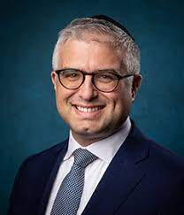

**Dovid Bashevkin**

In that interview, Dovid Bashevkin spoke about his own podcast 18Forty.org. On that website, his bio reveals that he is currently the director of education for NCSY, the youth movement of the Orthodox Union, and an instructor at Yeshiva University, where he teaches courses on public policy, religious crisis, and rabbinic thought.  He completed his rabbinic ordination at Yeshiva University’s Rabbi Isaac Elchanan Theological Seminary and is the author of Sin·a·gogue: Sin and Failure in Jewish Thought.

When examining Bashevkin’s website 18Forty.org I was attracted to a recent one hour and 35 minutes interview with Marika Feuerstein who is the granddaughter of the recently deceased Aaron Feuerstein that was first released last month on January 5th under the title of: “Marika Feuerstein – The Mentsch of Malden Mills.” I strongly advise readers of this column to google this podcast.

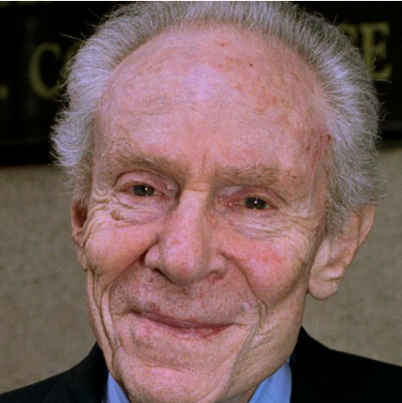

**Aaron Feuerstein and his granddaughter Marika Feuerstein**

Aaron Feuerstein, the CEO of Malden Mills headquartered in Lawrence, Massachusetts gained his 15 minutes of global fame whenOn December 11, 1995, (ironically his 70th birthday) the core buildings of his textile plant burned to the ground, in what has been described as the worst fire in the 20th-century history of his home state.

Mr. Feuerstein’s reaction was so stunningly against the grain of what smart businessmen should do that he became the subject of a 60 Minutes documentary titled “The Mentsch of Malden Mills.” Aaron could have simply collected the $300 million dollars in settlement from his corporate insurance policy and turned his back on the unfortunate employees of his now burned-out company and purchased a beautiful home anywhere in the world and give generous donations to whatever charities appealed to him.

**A Shocking Announcement that Made Him World Renowned**

But instead, he shocked not only other businessmen, but his own employees who thought that their immediate lives had gone up in smoke. Aaron Feuerstein immediately announced that he was going to pay all his employees their full salary plus their annual two-week holiday bonus for the next month along with their insurance premiums. Hence his new title as “The Mentsch of Malden Mills.”

He became such a hero that President Bill Clinton invited him to be a special guest at his 1996 State of the Union address where he was lauded to the entire nation for his selflessness. Aaron Feuerstein wound up paying $25 million in full salaries and health insurance premiums for his employees for three months until Malden Mills could be rebuilt and production restarted.

Dovid Bashevkin at the start of his podcast interview with Marika the granddaughter explained that unfortunately the story of the Mentsch of Malden Mills did not have a happy ending.

**What Happened in the Wake of the Fire?**

As he explains: “Rebuilding came with challenges that ultimately cost him the company. Marika Feuerstein tells the lesser-known story of his later life, and how the Feuerstein family regrouped in the wake of the fire.

“What happened in the aftermath of the fire?

“What were its effects on the Feuerstein family, who, until that point, had all worked in the business?

“How did Aaron Feuerstein, as well as the rest of his family, recover from the setbacks to lead a healthy life?”

One of inspiring points that Marika told Dovid Bashevkin was that since the company was founded by Orthodox Jews who believed in the importance of observing Shabbos it was a “company that was owned by Jews who didn’t make you work on Shabbos. And I guess the way that Henry set the company up and Sam and my grandfather continued this, if you could work every day but Shabbat and you were willing to get to that factory, you had a job and you weren’t going to lose it.

**A Safe Haven for Observant Jews**

“And so, it became a safe haven for all these observant Jews. They started Malden Knitting in 1907. So, I’d say it took a few years for it to really take off. But once it did, I mean, that was Pre-World War I, Jews had a place to go and work here. “And then during World War II, not only did, of course, observant Jews have jobs, they didn’t have to work on Saturday, but they saved so many Jews during the Holocaust because whoever they could get work visas to, they sent them. So, a lot of Holocaust survivors came, worked, got into the states because of their company.”

To listen to Dovid Bashevkin’s inspiring interview with the granddaughter of Aaron Feuerstein – simply click or google “Marika Feuerstein – The Mentsch of Malden Mills.”

*Reprinted from the February 25, 2022 edition of the Jewish Connection.*

**Pray for Peace in Ukraine**

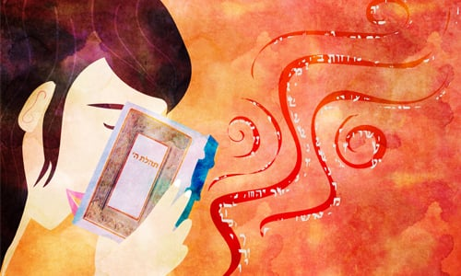

We pray for the safety of our Jewish brethren in Ukraine along with all people in the affected areas. We pray for a peaceful resolution to this conflict. We pray that the people affected have the strength and resources to make it through this trying time. And most of all, we pray for the day when “nations will beat their swords into plowshares … and not learn war anymore.”

Even as bombs drop and the war unfolds, the nearly 200 Chabad-Lubavitch emissary families throughout the length and breadth of Ukraine remain with their people, providing much-needed material aid, encouragement, and most importantly, spiritual strength and support.

No matter where you are, you can make a difference.

[Put a few coins](https://www.chabad.org/library/article_cdo/aid/4203668/jewish/15-Facts-About-Tzedakah-Every-Jew-Should-Know.htm) into a charity box (or swipe your credit card) for a worthy cause, [don](https://www.chabad.org/library/article_cdo/aid/4455097/jewish/14-Tefillin-Facts-Every-Jew-Should-Know.htm) [*tefillin*](https://www.chabad.org/library/article_cdo/aid/4455097/jewish/14-Tefillin-Facts-Every-Jew-Should-Know.htm), [light Shabbat candles](https://www.chabad.org/library/article_cdo/aid/4387042/jewish/15-Shabbat-Candle-Facts-Every-Jewish-Woman-and-Man-Should-Know.htm) before sunset this Friday, and know that you just introduced a very real point of goodness and kindness into a world that needs it more than ever.

Say a few heartfelt chapters of [Psalms](https://www.chabad.org/library/bible_cdo/aid/16222/jewish/Chapter-1.htm) (especially [Chapter 20](https://www.chabad.org/library/bible_cdo/aid/16241/jewish/Chapter-20.htm)), and know that you have introduced a dose of spiritual energy into a world that seems to be pulsating with negativity.

May G‑d protect our Jewish brothers and sisters and anyone in harm’s way.

Your friends at Chabad.org

*Reprinted from the February 24, 2022 dispatch of Chabad.Org*

**Rav Avigdor Miller**

**On Wartime Lessons**



**QUESTION: What should be our reaction when we hear about wars and other upheavals that are happening in other parts of the world?**

**ANSWER:** When you see trouble among, let’s say, in Africa, in the Congo, and they are massacring entire tribes or massacring each other, or if you hear that the brown peoples in Vietnam are trying to destroy each other, or in Korea, North Korea and South Korea they’re warring with each other, or in China, the nationalists and the communists are fighting against each other, all these phenomena shouldn’t be lost upon us.

And one of the purposes is to make us think, “Suppose we lived there; can you imagine what suffering we would undergo.” It’s a very great suffering to live in Vietnam.  People are constantly in terror, in commotion.  Their lives are ruined.  And how many of them have been destroyed? How many have been maimed, orphaned, widowed? How many are refugees?  They’re afraid to sleep at night.

If we can live in peace, if we can get up in the morning after a good night’s sleep – you know what it means to sleep in peace?  We don’t even think twice about it.  Maybe some people are worried, so you check to see that the doors are locked at night, the windows are closed. Very good. But then you go to sleep in peace.  Do you know what a luxury it is to go to sleep in peace?  To be able to put your head on your pillow without any fear and to fall asleep peacefully is a very great bracha.

We’re not afraid that somebody will shoot machine guns through our window or burn down the house. We’re not afraid that all of a sudden at night, there’ll be an invasion.  When you go to sleep in America, you know that nobody is going to wake you up.  Nobody will bother you.  You’re sleeping in peace.

Sleeping peacefully is a precious commodity.  So tonight, when you say השכבנו think about that. השכבנו ה’ אלקינו לשלום – let us lie down in peace. Appreciate that! If you just came here to learn that, it’s worthwhile.  השכבנו ה’ אלקינו לשלום – we should be able to sleep in peace.  It’s a big bracha!

Now this is such a precious commodity that we have to pay for it.  And the minimum payment is gratitude to Hakodosh Boruch Hu. That should be our minimum reaction to the news of upheavals in the world.

*Reprinted from the February 25, 2020 email of Toras Avigdor. Adapted from Tape #13.*

**The Power of Teshuva (Revelation) Following a Jew’s Concealment from G-d**

**From the Talks of the Lubavitcher Rebbe**

**Rabbi Menachem Mendel Schneerson, Zt”l**

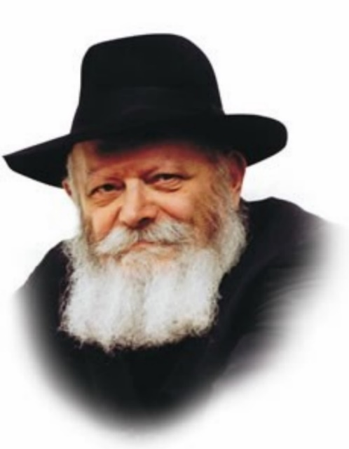

This week's Torah portion is Pekudei, the last Torah portion of the Book of Exodus, which immediately precedes Vayikra, the first Torah portion of the Book of Leviticus.

Accordingly, an intrinsic connection exists between the two:

At the end of Pekudei we are told that a cloud descended upon the Sanctuary. The purpose of a cloud is to conceal; the cloud prevented Moshe from entering the Sanctuary.

The theme of Vayikra, by contrast, is revelation. "G-d called to Moshe" -- to reveal Himself to him.

Sequentially, the revelation of Vayikra follows the concealment of Pekudei. And a revelation which comes after a concealment is much more obvious than one which occurs without a prior concealment.

**Before One Does Teshuva,**

**One is Estranged from G-d**

In the service of man, the revelation that follows a period of concealment is teshuva (repentance; literally "return"). Before the person did teshuva he was estranged from G-d, distanced from His Torah and mitzvot, i.e., in a state of concealment. His act of teshuva, his return to G-d, constitutes the revelation.

Indeed, we find that Jews who repent of past misdeeds (baalei teshuva) merit a higher revelation of G-dliness than those who were always righteous! For the revelation which follows a concealment is a more exalted one.

When a person does teshuva, his "deliberate sins are considered as merits." As our sages declare: "In the place where baalei teshuva stand, even the completely righteous cannot." The tzadik is successful in completely banishing evil. But a baal teshuva, someone who returns to G-d with all his heart, transforms the evil he has done into good -- so much so that even his deliberate sins are considered as merits! By doing teshuva, he turns darkness into light. This is the revelation that follows the concealment.

**No Matter How Low One’s Spiritual**

**Level, One Must Never Despair!**

What can we learn from this? That regardless of our present spiritual condition we must never despair! We must never think that our spiritual state is so lowly that no hope exists. On the contrary: It is precisely after a period of concealment that the highest revelation of G-dliness is possible!

Past generations of Jews were on a much higher spiritual level than our own, but they were further removed from the Redemption. Our generation, however, is the generation of Moshiach's coming. Because the greatest revelation of the Redemption follows the lowest descent, we must take heart and strengthen ourselves in advance of the light about to break forth. In this manner we will soon merit the true and complete Redemption -- the revelation that follows the concealment -- when "the night will illuminate as the day."

*Reprinted from the Parshat Pekudei 5757/1997 edition of L’Chaim. Adapted from Likutei Sichot Vol 1.*

**Rabbi Berel Wein**

**On Parshas Pekudei**

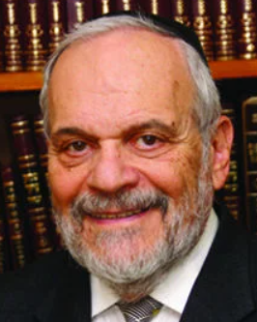

The basic lesson in this week's Torah reading is accountability. G-d demands from Moshe and the others who formulated and created the Tabernacle in the desert, to account for all the material that was donated by the Jewish people for that purpose. The last piece of silver that was donated had to be accounted for, but Moshe was distressed that he could not account for 1000 measures of the silver. He finally remembered that this donation of silver was used for constructing hooks that bound the tapestries of the Tabernacle together.

The hooks must" shout" to remind us of their presence, and to make Moshe's accounting complete and accurate. Accounting is a very painstaking project. Most people view it as bordering on boring. Nevertheless, there is no commercial enterprise that can successfully exist without good and accurate accounting practices.

The financial accounting in our Parsha regarding the materials that were used in the construction of the Tabernacle is a template for proper human behavior concerning the use of resources in all areas of life. This is especially true in matters that border on religious institutions that are held to the highest of all standards and are to be above any suspicion of corruption. The Priest of the Temple wore garments that had no pockets and could not conceal any hidden items of value that might be removed from the Temple.

This overriding meticulous standard and value of accountability is not limited to financial matters. Judaism teaches us that we are all accountable for our actions - behavior, speech, attitudes and even thoughts. We were created as being responsible creatures – responsible to the creator and to the other creatures that exist with us on this planet. We are given talents that are unique to each one of us. The challenge that is put before us is how those talents and abilities can be used for good and noble causes.

There are many who think that the gifts that they have been given are for their exclusive use, and that there is no need or obligation to share them with others. They are sadly mistaken in this view. People are accountable for what they have, as they were for the supposedly insignificant amount of silver that was used to construct hooks that kept the tapestries together.

King Solomon states in Kohelet that one should realize that all actions and behavior will eventually be weighed on the scales of heavenly justice. We live in a time when accountability, to a  great extent, has been replaced by excuses, social engineering, economic and psychological theories. All of these are used only to avoid the issue of accountability. To be human is to be responsible, and that is the message not only of this week's Parsha, but of everything in Judaism.

*Reprinted from this week’s website of rabbiwein.com*

***A Continental Carved Ivory Seder Group, Probably Dieppe, Late 19th Century which sold at the 2013 Sotheby’s Judaica auction for $22,500.***

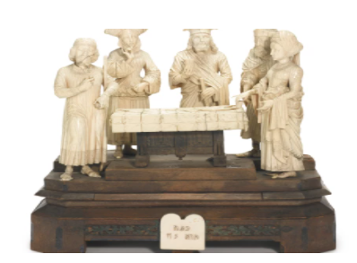

**Shtadlanim:**

**Rabbi Dr. Israel Miller**

**By Steve Lipman**

[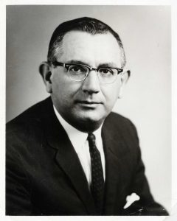](https://jewishaction.com/content/uploads/2021/11/Miller1-scaled.jpg)

**Rabbi Dr. Israel Miller**

**Courtesy of Yeshiva University Archives**

In 1988 Rabbi Dr. Israel Miller (1919-2002) faced some hardball questions from the hardest thrower in US journalism, which he treated as softball tosses.

In a *60 Minutes* interview, correspondent Mike Wallace, not always regarded as favorable to Jewish or Israeli issues, confronted Rabbi Miller, a vice president of the pro-Israel AIPAC lobbying organization, with documents that purportedly showed that AIPAC had illegally urged financial support for some political candidates.

Without blinking, the rabbi discounted, accurately, the documents as not representing AIPAC. Then he explained the then-wide support of US Jews for a strong Israel, some four decades after the end of the Holocaust. “Had you and I been in certain parts of Europe, we would have walked to Auschwitz together,” Rabbi Miller told Wallace, who was born Myron Wallace in a Jewish family in Boston.

Wallace, not generally known to be part of the Jewish community, also did not blink.

**A Graduate of Yeshiva University**

Rabbi Miller, a graduate and ordainee of Yeshiva University who during his career dealt with presidents and prime ministers, had subtly made his point. Later that day he described the interview to his family.

“My father outed Mike Wallace as being Jewish,” says Rabbi Michael Miller, executive vice president emeritus of New York City’s Jewish Community Relations Council (JCRC), who followed his father into Jewish communal advocacy activities.

“Dad was certain,” Rabbi Michael says, that the “outing” part of the interview “would end up on the cutting room floor,” not part of the report aired on CBS.

No prophet (that part of the interview *did air*), Rabbi Miller was an advocate for several Jewish causes over a half-century career, serving as a pulpit rabbi in the Bronx before joining YU as senior vice president in 1979.

The rabbi played an active role as a volunteer, often as the public face and voice of the Jewish community, on behalf of the JCRC, Holocaust survivors, Soviet Jews and other causes, as well as several Orthodox and Zionist organizations.

**The Glory of Israel**

**is Not a Falsehood**

“There was a verse he would invoke in the family, ‘*Netzach Yisrael lo yeshaker,* the glory of Yisrael is not a falsehood’” [[1 Samuel 15:29](https://www.sefaria.org/I_Samuel.15.29?lang=he-en&utm_source=jewishaction.com&utm_medium=sefaria_linker)], his son says. Rabbi Miller translated *netzach*as “destiny.” “He did everything in his power,” Rabbi Michael says, “to ensure the *netzach Yisrael.*”

**Rabbi Miller played an active role as a volunteer, often as the public face and voice of the Jewish community, on behalf of the JCRC, Holocaust survivors, Soviet Jews and other causes, as well as several Orthodox and Zionist organizations.**

“The Jewish community was fortunate to have such a wonderful person like Rabbi Miller” as its representative, says Charles Rangel (D-NY), who as a member of the House of Representatives for forty-six years, frequently dealt with Rabbi Miller. He called the rabbi “a credit to the Jewish people. You never felt you were different from him,” even if you were a member of a different religion.

**Not Just Lofty Rhetoric**

“It wasn’t lofty rhetoric. He knew what to say and when to say it,” Rabbi Michael says. He adds that his father’s soft-spoken yet tough personality (“he was tough when he needed to be tough,”) along with his chairmanship of the Conference of Presidents of Major American Jewish Organizations, a consensus body, made him into an effective advocate of Jewish interests. “People wanted to talk with him, they sought his advice.”

Most impressively, for two decades he served as president of the Conference on Jewish Material Claims Against Germany (“the Claims Conference”), the designated representative of the Jewish community to negotiate for and disburse funds to individuals and organizations.

Rabbi Miller’s negotiations with German and other European governmental offices resulted in historic compensation and restitution agreements, which led to the payment of some $2 billion (in today’s dollars) to more than 400,000 Jewish Holocaust survivors in over sixty countries.

[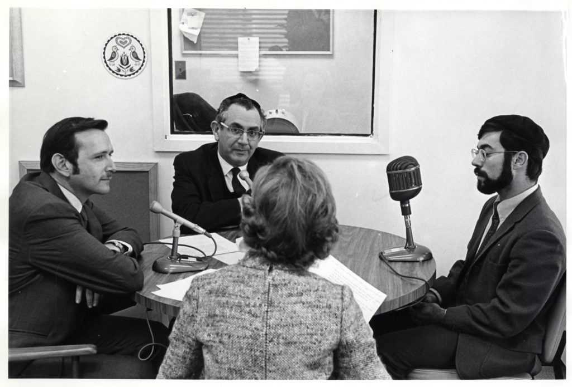](https://jewishaction.com/content/uploads/2021/11/Miller2-scaled.jpg)

**Rabbi Dr. Israel Miller (center) speaking with WEVD, New York City’s famous Jewish radio station, in 1969 on the plight of Soviet Jewry. Courtesy of Yeshiva University Archives**

Gideon Taylor, the new executive vice president of the JCRC who had previously served in that position at the Claims Conference, calls Rabbi Miller “a giant . . . one of those unsung heroes.”

“He was a uniter,” who worked with Saul Kagan, executive vice president of the Claims Conference, to arrange expanded pensions for Holocaust survivors from reunified Germany. “Tens of thousands of people got pensions” because of Rabbi Miller’s work, Taylor says. “This for him was an obligation of the Jewish people. This was the essence of Jewish leadership.”

In addition, Rabbi Miller sought the return of Jewish property stolen during the Holocaust, the sale of which amounted to some $500 million, which was subsequently used to fund organizations assisting destitute Holocaust survivors.

“He infused Torah teaching into what he did, it was the core of his beliefs,” Taylor says. “When he spoke, everyone listened.”

Rabbi Michael says he met Mike Wallace several years ago at a Jewish community event, and introduced himself as Rabbi Israel Miller’s son; maybe the journalist would have an unpleasant memory of his public outing as a Jew by the rabbi, Rabbi Michael thought.

On the contrary. “That was one of the best interviews I ever did,” the journalist told him.

Reprinted from the Winter 2021 edition of the OU (Orthodox Union’s) Jewish Action magazine. Steve Lipman is a frequent contributor to Jewish Action.

**The Legacy of the Arizal**

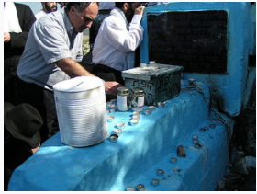

**The burial place of the Arizal in Safat, Israel**

The Arizal (5294-5332; 1534-1572) Rabbi Isaac Luria has become famous as the "Ari," the holy lion; Ari represents the initials of “Ashkenazi Rabbi Isaac” As his name indicates, his family originally lived in Germany, whence they had wandered to Jerusalem. There the man was born who was to play a magnificent role not only in that century of spiritual and cultural revolutions, but down to our very days.

At a very early age Rabbi Isaac Luria lost his father and he went to Cairo, Egypt, where Mordecai Frances, the rich brother of his mother took care of his upbringing and education. He attended the Yeshiva of Rabbi David ben Zimri, the Chief Rabbi of Egypt, known as the author of many great commentaries and responsa under the name of Radbaz.

The brilliant youngster became one of the close disciples of the Radbaz, and his studies of the Talmud early promoted him to heights of scholarly achievements. The only extant product of his work in Gemara and Halachah, is a commentary to Zevachim. When Rabbi Mordecai Frances saw the great success of his young nephew, he gave him his daughter as a wife and assured him of sufficient means for a livelihood.

Yet the deep and introspective nature of Rabbi Isaac Luria was not satisfied by the study of Halachah alone. He acquired knowledge of Cabbala and devoted his entire life to its study and dissemination. At an early age he began his long stays in the solitude of the Nile River. For seven long years he lived all by himself, immersed in the study of the "Zohar," the main work of Cabbala, and other minor Cabbalistic writings, and returned only once a week, on Shabbos, to his family in Cairo.

**Tireless Efforts to Penetrate the Inner Chambers of Torah**

Possessed of a fiery and noble soul, he was wholly attracted to the universe of deeper wisdom and sought the meaningful interpretation of all phases of life, nature, and prayer. He spent many days in fast, prayer and study. In his tireless efforts to penetrate the inner chambers of the Torah, he discovered much of the true meaning of the Jewish faith. He was able to work out a whole system of a Cabbalistic doctrine on the world, and on the role of the Torah and its commandments in the life of man. Filled with the fire of inspiration and enthusiasm, he set out to cleanse the world of the spirit of impurity and to replace the rule of evil by the recognition of G-d. About the year 1569, he took his family and migrated to Jerusalem and from there to Safed, the center of all study and practice of Cabbala.

Soon a large group of disciples gathered about him and listened to his interpretations of the deeper meaning of all happenings and occurrences in the world. More and more men flocked to him and accepted the tenets of a holy and ascetic life which the Ari Hakodosh set down as a necessary requirement for participation in the circle of his followers.

**Inspired a Deeper Meaning for Prayer**

Under his inspired guidance, prayer assumed a deeper meaning, since the significance of each word and phrase was interpreted by him. The fast days and holidays turned into genuine turning points of religious life, and the Shabbos became the pivot of holy experience and inspiration, for it was devoted exclusively to spiritual activity.

Each Sabbath meal, filled with songs of holy content, many of them written and composed by the Ari Hakodosh himself, was an offering to G-d, and the Melaveh Malkeh represented a stirring tribute to the departing Sabbath. In such and similar manner, most aspects of the Jewish life and faith were given new content and color.

Rabbi Isaac Luria's teachings were spread wide and far and reached all corners of the world, wherever Jews had settled. Amongst the most ardent exponents of the Ari's teachings was his disciple and successor to the leadership of the Cabbalists, Rabbi Chaim Vital.

Rabbi Chaim Vital recorded the revelations and explanations of his great master, and they were among the most printed books in those early days of the printing press. Another ardent disciple and exponent was Rabbi Israel Saruk.

Rabbi Isaac Luria's personality inspired all the great men who had penetrated deeper than most mortals, into the world of Cabbala. The Ari died at the age of 38 years, mourned by the entire Jewish people. Despite his short life, he left an indelible impression on religious Jewish life and religious reaching.

He introduced many holy Minhagim (customs) which have become part and parcel of our customs and services. His songs and prayers have been widely adopted and partially incorporated into the Siddur. Entire communities guide themselves by the "Nusach HoAri" and much of his teachings has been used to form the basis of the great Chassidic movement.

Due to his influence and inspiration Judaism was able to withstand the onslaughts of many creeds and ideas that were promoted during the sixteenth and seventeenth centuries. He certainly counts among the holiest and most important leaders of the Jewish people. (Rabbi Nissan Mindel - Chabad.Org)

*Reprinted from the Parshat Pekudei 5782 email of R’ Yedidye Hirtenfeld’s parsha sheet – whY I Matter for the Young Israel of Midwood in Brooklyn, NY.*

**A Message from the Kalever Rebbe**

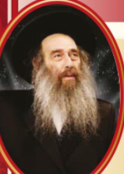

The first time the *Toldos Yaakov Yoseif*  (Rabbi Yaakov Yosef of Pollonya , 1710-1784) met the *Baal Shem Tov (Rabbi Yisroel ben Eliezer, 1698-1760)*, they had a conversation about the concept of *hashgacha pratis*, Divine Providence.

During this conversation, the *Baal Shem Tov* explained that everything someone hears or sees, everything, is with an exacting Divine Providence, a Divine design, a *hashgacha pratis*.

Therefore, whenever someone hears or sees something, when they experience anything in their lives, there is a Divine message within that experience that is entering his life for a purpose. Therefore, a person must reflect and contemplate: what is the message that Hashem is sending me through this experience?

This, explained the *Baal Shem Tov*, is the equivalent of a *bas kol*, a heavenly voice speaking directly with the individual.

While they were meeting, a non-Jewish handyman was passing by the home and knocked on the door. When he came into the room where the Baal Shem Tov was, the handyman asked, “Is there anything in the house that I might be able to fix?”

“There is nothing here that needs fixing,” answered the Baal Shem Tov.

“Perhaps,” inquired the handyman, “there is some small thing in the house that could use fixing?”

The *Baal Shem Tov* turned towards the *Toldos Yaakov Yoseif* and said, “See! Hashem is sending me this non-Jewish handyman to awaken with in me the realization that I still have work to do, that I still have areas in my *ruchniyos*, spirituality, and my *Avodas Hashem*, that needs some repairing.”

The *Toldos Yaakov Yoseif* couldn’t accept the idea that Hashem was sending a message to the *Baal Shem Tov* from the words of a non-Jew. And, he told the *Baal Shem Tov*, “I am unable to accept what the Rebbe is teaching me.”

“You are able to, you just don’t want to,” answered the *Baal Shem Tov*.

With that, the *Toldos Yaakov Yoseif* left to return to his lodgings. On the way, he passed by a non-Jew whose wagon had turned over and was stuck. He was trying to find someone to help him turn the wagon right side up. When he saw the *Toldos Yaakov Yoseif*, he asked him, “Can you please help me lift my wagon?”

The *Toldos Yaakov Yoseif* was already older and frail. “I am unable to help,” answered the Rebbe.

“You are able, you just do not want to, replied the non-Jew.

When the *Toldos Yaakov Yoseif* heard this wagon driver use the same exact terminology as the *Baal Shem Tov*, he realized that this was Hashem sending him a message. He accepted the teaching of the *Baal Shem Tov* and became a devout follower of his Rebbe.

Reb Yaakov Glinsky related a story that encapsulates this very idea and it worthwhile for everyone to hear:

Reb Yaakov was learning in the Novardik Yeshiva leading up to the outbreak of World War II.

One day, the Rosh HaYeshiva asked him to go to the Jewish bakery near the town’s square and bring back bread for the yeshiva students.

When Reb Yaakov reached the town square, he saw a large crowd gathering awaiting a critical speech by the Polish president. At the time, there was a tremendous debate in the parliament whether Poland should succumb to Hitler’s demand for the port city of Danzing or to enter the war. Reb Yaakov waited with the crowd. A few moments later, the Polish president began his speech saying, “As you all know, the leader of Germany is demanding that we give him Danzing. If all he wanted was this port city, I would be willing to offer it in exchange for our sovereignty. However, Hitler doesn’t want Danzing. He wants Warsaw. It is just easier now to ask for Danzing. But make no mistake about it. Appeasing Hitler now will only delay the inevitable: we will have to fight the Nazis. I rather not give them Danzing now, making their conquest easier. Therefore, I reject the German proposal.``

All of Poland knew that this declaration would be the beginning of World War II for the Polish people. The Jewish baker immediately shut his store and went home to prepare with his family. Reb Yaakov had to return to the yeshiva without the bread.

When he returned to the Yeshiva, they asked him where the bread was. And, he answered, “I was unable to get any bread, but I did get a Divine Calling from the Polish president.”

The students were puzzled, and Reb Yaakov explained everything that he saw and heard in the town square. And, then he explained, that everyone is constantly battling their *yetzer harah*, they are constantly engaging in a war.

At first, the *yetzer harah*, comes and attacks the seemingly “meaningless” customs, traditions, the less “important” Jewish laws. He demands small concessions that would appear to be harmless and a worthwhile compromise. However, that won’t satisfy the *yetzer harah* for long. His goal is the utter spiritual defeat and annihilation of the individual.

He will begin by demanding small concessions but he will inevitably start waging war against more critical elements of a Torah life. He will attack kosher, Shabbos and other pillars of Yiddishkeit. Therefore, the Y*id* must draw the battlelines early. They must not concede even the smallest, most lenient of the Jewish laws.

The Y*id* must fight the *yetzer harah* from the very beginning. Wage the war now, because it is inevitable.

This story teaches us how important it us to even glean lessons from the words we hear. As the Maggid of Mezritch taught that we must elevate and internalize the words of the warring non-Jewish nations because they too carry an important Divine lesson for our *Avodas Hashem*.

In Pirkei Avos (4:1) the Mishna teaches that a wise person is someone who learns from everyone. The Baal Shem Tov explained that there are Divine messages, lessons to be learned from everyone, even non-Jews. They might be discussing or engaging in things of this world, and the *Yid* needs to take those lessons and apply them to their spiritual growth.

This is what our *pasuk* means. When the *pasuk* says, “And every wise hearted person among you shall come,” teaches us that everyone we see and hear in this world needs to be used for our spiritual growth. As the pasuk continues, “make everything that the L-rd has commanded.” Everything should be utilized for the life Hashem has commanded us to live, a life of Torah and mitzvos.

*Reprinted from the Parshas Vayakhel 5782 message of the Kalever Rebbe, Grand Rabbi Moshe Taub, shlita.*